East Group guide to:

VASP Molecular Dynamics Code

From the VASP manual:

“VAMP/VASP is a package for performing ab-initio quantum-mechanical molecular dynamics (MD) using pseudopotentials and a plane wave basis set.”

The approach implemented in VAMP/VASP is based on an exact, DFT-based evaluation of the instantaneous electronic ground state at finite temperature (with a free energy as variational quantity) at each MD-step using efficient matrix diagonalization schemes and an efficient Pulay mixing. [vaspmaster, 2007]

“These techniques avoid all problems occurring in the original Car-Parrinello method which is based on the simultaneous integration of electronic and ionic equations of motion. The interaction between ions and electrons is described using ultrasoft Vanderbilt pseudopotentials (US-PP) or the projector augmented wave method (PAW). Both techniques allow a considerable reduction of the necessary number of plane-waves per atom for transition metals and first row elements. Forces and stress can be easily calculated with VAMP/VASP and used to relax atoms into their instantaneous groundstate.”

Contents:
- Theory p.2
- Input files p.4
- Output files p.6
- How to prepare a VASP run p.7
- How to submit a VASP run p.8
- VASM errors (slurm files) p.9
- How to analyze results p.11
- VMD tips p.12

1. Theory

1.1 Molecular Dynamics
Molecular dynamics (MD) simulations are simulations of the temporal (time-dependent) behaviour of systems at the atomic level. Atoms are moved in discrete timesteps Δt, typically 1-3 fs. When combined with visualization software, it allows us to watch what is happening with the human eye: it is possible to visualize a system equilibrating or a chemical reaction taking place.
In quantum mechanical MD, the atoms are moved according to Newtonian classical mechanics, but the forces are computed according to quantum mechanics. A particle, initially at position and velocity and subject to a force during time t, is moved to a new position according to the classical physics relation:
(1) , ,
where the acceleration is assumed constant in the time interval t. However, is not constant so this is an approximation that improves as the timestep is made smaller.
Without temperature control, a molecular dynamics simulation behaves as a microcanonical ensemble (constant N,V,E). The resulting temperature is difficult to predict and can be quite high if the system is started with artificially high potential energy (i.e. bad initial geometry). To switch to a canonical ensemble (constant N,V,T) a thermostat algorithm is needed to control the temperature. Temperature is related to particle velocities via the principle of equipartition of energy.
(2)
where K is the total kinetic energy, N is the number of particles, and k_{B} is the Boltzmann constant. The simplest thermostat algorithm is
(3) ,
applied each timestep, but it does not work well. A better algorithm is the Nose-Hoover thermostat, employing a friction coefficient ζ and a heat bath Q:
(4) , ,
1.2 Computation of Forces
The force F acting on an atom depends on the approximation for U, the quantum mechanical potential energy for the nuclei (ions) of a system. For contributions to U due to electrons, VASP uses DFT, although not Becke-based ones. The default is a local (LDA) one, but better gradient-corrected (GGA) ones are available.
VASP was designed to simulate condensed phases. It does this by studying a unit cell of atoms, and replicating the cell in all dimensions, using periodic boundary conditions (PBC), to consider forces from atoms outside the cell. (For liquids, a cubic cell is fine, but for crystals, Bravais lattices become important.) Due to the use of PBC, VASP uses plane-wave (PW) basis sets (sines and cosines) instead of atom-centred spherical harmonics (s,p,d,…). Bloch’s theorem suggests this benefit:
(5) ,
Here is the electronic wave function at a physical point for a quantum state described by a k-vector. Think of the k-vector as a set of three quantum numbers, like (n_{x},n_{y},n_{z}), but the quantum numbers aren’t integers, and vary essentially continuously if one is considering an infinite solid or liquid. The theorem says that, if is a replication vector, then the electronic wave function must have the same magnitude in both places, but possibly offset by a plane-wave phase factor .
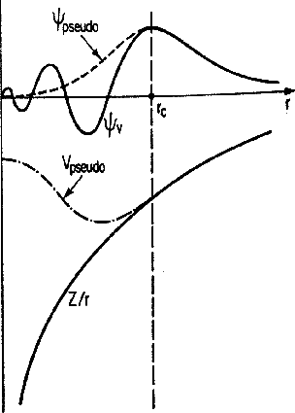
In practice, the set of plane waves is restricted to a sphere in reciprocal space most conveniently represented in terms of a cut-off energy.
The principal disadvantage of a PW basis set is the large number of basis functions needed to obtain accurate Kohn-Sham orbitals. VASP solves this problem by useing pseudopotentials, simple energy corrections to account for contributions from core electrons and the nucleus (yes, there is one for H atoms). The simplification idea is shown at right. Pseudopotentials remove the need to provide orbitals for core electrons. Pseudopotentials are atom-specific (i.e. one for carbon, one for nitrogen, etc.) and method-specific (i.e. one for LDA, one for PW91-GGA, one for PBE-GGA).

2. Input files

POSCAR: Bravais-lattice cell shape and size, and initial atom positions
POTCAR: the pseudopotentials for each atom used
KPOINTS: integration grid over k-space; important only for metals/semiconductors
INCAR: algorithm choices and parameters

POSCAR example:

Water ! title
1 ! scaling parameter for cell. Result is in angstroms.
12.000 0 0 ! cell dimensions
0 12.000 0 ! cell dimensions
0 0 12.000 ! cell dimensions
H O ! [optional?] atom types involved (MUST match POTCAR ordering)
6 3 ! how many of each (32 hydrogens, 16 oxygens)
cart ! Cartesian coordinates; another option is Direct (0-1 values).
1.00000 1.00000 1.00000
1.00000 2.00000 1.00000
1.00000 1.00000 2.00000
4.13645 4.00000 4.00000
5.00000 4.20025 4.00000
4.00000 5.00000 4.00000
8.11112 8.00000 8.00000
9.00000 8.13131 8.00000
8.00000 8.00000 9.05650

- Lines 3-5: unit cell replication vector. Here, a cubic cell of width 13.167 Angstroms.
- Lines 9-17: initial coordinates. Could follow by true/false movement flags (e.g. T T F).

POTCAR example:

H
<Insert pseudopotential data here, ~1500 lines>
O
<Insert pseudopotential data here, ~1500 lines>

This was from a water/ice simulation. Order of atoms MUST match POSCAR ordering!

KPOINTS example: (ground state (k=(0,0,0) ) only)

Auto-Generation
0
Auto
10 ! good for cells > 6.6 Å wide. Use 1 if pure insulators (gamma-point only).

INCAR example:

NWRITE = 2
PREC = Normal ! standard precision
ISMEAR = 0 ; SIGMA = 0.1
NELMIN=4 ! minimum # electronic steps per geometry
IALGO=48 !RMM-DIIS for electrons (good for MD)
LREAL=A !evaluate projection operators in real space
LWAVE=.FALSE.
LCHARG=.FALSE.
ENMAX = 400
IBRION = 0 ! molecular dynamics
NSW = 1000 ! number of timesteps
POTIM = 1.0 ! timestep 1 fs
SMASS = 0
TEBEG = 773 ; TEEND = 773 ! temperature is 500 Celsius
GGA = 91 ! requests DFT = PW91. Could try B3 (maybe calls B3LYP?)
IVDW = 12 ! adds van-der-Waals correction (why 12?)

Tag | Description
IBRION | Determines the specific algorithm for how the ions (nuclei) are updated and moved. IBRION=0: time-dependent molecular dynamics, IBRION=1: quasi-Newton (RMM-DIIS), best if the initial guess is accurate. IBRION=2: conjugate gradient, best for tough cases. IBRION=3: damped molecular dynamics, best if the initial guess is poor.
POTIM | For IBRION=1, 2 or 3, POTIM is a scaling constant (default 0.5) for moving the nuclei. For IBRION=0, POTIM is the time step for ab-initio molecular dynamics.
EDIFF | The energy-based criterion in eV for determining electronic SCF convergence. Convergence is deemed complete if the total (free) energy change and the band structure energy change (change of eigenvalues) between two steps are both smaller than EDIFF. Default: 10⁻⁴.
EDIFFG | The criterion for determining ionic (nuclear motion) convergence. If positive, it is an energy-based criterion like EDIFF. If negative, it is a force-based criterion: convergence is deemed complete if the forces on all nuclei ar all smaller than |EDIFFG| in eV Å⁻¹. Default: EDIFF*10.
SMASS | SMASS controls the velocities during ab-initio molecular dynamics (IBRION=0, 3). If negative, a micro canonical ensemble is simulated (constant energy), and the value indicates the algorithm (-3, regular; -2, fixed velocities; -1 annealing). If positive or zero, a canonical ensemble is simulated (constant temperature) using the algorithm of Nosé, and the value indicates the damping level of temperature oscillations (2, maximal damping; 0, no damping). If IBRION=3, then SMASS=2 corresponds to a steepest-descent algorithm.
3. Output files

OSZICAR: basic output, updated continually
nohup.out: standard output (OSZICAR plus some things like warnings)
OUTCAR: complete output (everything except coordinate history)
XDATCAR: coordinate history (useful for movies and taking radial distributions)
VASPRUN.XML: the OUTCAR in a format used by P4VASP viewer
CONTCAR: the last geometry, in POSCAR format (useful for continuation runs)
There are several other output files too.

OSZICAR portion example:

reading files
WARNING: wrap around errors must be expected
entering main loop
N E dE d eps ncg rms rms(c)
RMM: 1 -.13238703E+04 -.132E+04 -.934E+02 56 .28E+02
RMM: 2 -.13391360E+04 -.152E+02 -.982E+01 82 .54E+01
RMM: 3 -.13397892E+04 -.653E+00 -.553E+00 72 .13E+01 .14E+00
RMM: 4 -.13400939E+04 -.304E+00 -.287E+00 84 .48E+00 .39E-01
RMM: 5 -.13401306E+04 -.366E-01 -.322E-01 69 .35E+00 .17E-01
RMM: 6 -.13401489E+04 -.183E-01 -.169E-01 75 .74E-01 .66E-02
RMM: 7 -.13401516E+04 -.267E-02 -.250E-02 68 .47E-01 .37E-02
RMM: 8 -.13401522E+04 -.567E-03 -.489E-03 53 .15E-01 .90E-03
1 T= 305. E= 0.48418874E+02 F= 0.46447673E+02 E0= 0.46517274E+02 EK= 0.19712E+01 SP= 0.00E+00 SK= 0.98E-05

This is from a molecular dynamics run. The middle lines are electron convergence lines. The last line is an energy summary for that nuclear geometry step:

T is the temperature (Kelvin)
E is the total energy of the extended system (F+EK+SP+SK).
F is a “partly” free energy for the system (E0 if insulators)
E0 is the ground-state potential energy for nuclei (F – TS_{elec}): E0 = E_{elec}(σ0) + V_{nuc}
EK is the kinetic energy of nuclei: E0 + EK would be internal energy U(T) for insulators
SP is the potential energy of the Nose heat bath
SK is the kinetic energy of the Nose heat bath

- The Nosé thermostat adds an extra degree of freedom to ion motion (now 3N+1). This is called the extended system. An NVT (canonical) ensemble for the real system is equivalent to, and performed as, an NVE (microcanonical) ensemble for the extended system.
- If E drifts too much (maybe more than 2 eV/1000 steps), reduce the timestep.
- F and E contains some electronic entropy (due to a smearing parameter σ used to aid in integration); hence the VASP manual calls them “free” energies. However, they do not contain nuclear-motion entropy, so don’t confuse F with Gibbs or Helmholtz energies.

4. How to prepare a VASP run

1. Prepare a fresh directory for the run, to contain all the files.
2. Prepare POSCAR: initial geometry could be prepared with GaussView and Excel.
3. Prepare POTCAR: copy from other runs. If you are using a new kind of atom, then:
a. cd /usr/local/share/vasp/vasp5-potentials/potpaw_PBE
b. make a new POTCAR file in one step with the cat command and listing the atoms you need. For instance, for carbon/hydrogen/oxygen systems:
cat {C,H,O}/POTCAR > /home/dextrose/[username]/newpotcar
c. move “newpotcar” to POTCAR in your desired directory
4. Prepare INCAR file. (See example, previous pages.)
5. Copy KPOINTS file from old run.
6. Move these 4 files to a fresh directory on Graham (see how to submit, below).
7. Continuation runs: copy INCAR, POTCAR, KPOINTS, and CONTCAR from your previous run into a new directory, and rename CONTCAR to be POSCAR. Then run.

5. How to submit a VASP run

Submitting on Graham: see next page (copied from Dr. East website, Digitall Alliance tips).

Submitting on Dextrose NO LONGER WORKS. Here is how we used to do it (in case we need to try it again): From within the directory where these VASP input files are located on Dextrose we would run by typing:

bsub -n A -R “span[ptile=12]” -J filename -oo stdout -eo stderr \ /opt/platform_mpi/bin/mpirun -e MKL_NUM_THREADS=1 -lsf vasp5

where A is any multiple of 12 (12, 24, 36…) and filename is the name you are giving to the run for Dextrose to keep track of. This puts one process on one core, so if you asked for A=24, you would get 24 processes on 24 cores, which would span a total of 2 nodes. This is the optimal way to run VASP on Dextrose. Use bhist and bjobs to monitor the runs in the PUTTY window, and bkill followed by the job number to terminate the job if necessary.

Running VASP on Digital Alliance’s Graham

Accessing Digital Alliance’s Graham supercomputer:
Same as for using Gaussian on Graham.

Running VASP on Graham:

- Prepare a typical VASP run directory (e.g. pyr5ac15.dir)
- Place input files in this directory (INCAR, POSCAR, POTCAR and KPOINTS files). POTCAR can still be built on Dextrose (see the East group VASP tips document).
- Prepare bash shell script file vasp_job.sh. An example is:
#!/bin/bash
#SBATCH --ntasks=16 # number of MPI processes
#SBATCH --mem-per-cpu=4G # memory
#SBATCH --time=3-00:20 # time (DD-HH:MM)
module load intel/2020.1.217 intelmpi/2019.7.217 vasp/5.4.4
srun vasp_std
Notice the ‘5.4.4’. You can only run the VASP software for which you have a license.
Refer to https://docs.alliancecan.ca/wiki/VASP if you have troubles running VASP on Graham.
Other notes: the number of ntasks – nodes – should optimally be set to 12-30, but wanting lots of notes means longer queue times. Make sure memory is at least 4G, or else your run may quit due to calculations not finishing.
- Place the vasp_job.sh file into the same directory (e.g. pyr5ac15.dir)
- Go into the pyr5ac15.dir with PuTTy. (cd /pyr5ac15.dir).
- Type ls to ensure your directory looks like this:
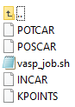
- “sbatch vasp_job.sh” into PuTTy to submit your job.

Other useful commands:
sq Lists all your jobs, PD = pending, R = running
scancel <JobID> Cancels your job (grab JobID from sq command)
squeue Shows everybody’s jobs (probably huge)

- VASP run errors (Slurm files)

Slurm files are useful for detecting what went wrong in your run. They appear as:

Here are some common errors and fixes.

`module load intel/2020.1.217 intelmpi/2019.7.217 vasp/<5.4.4>'

- This is due to leaving <> brackets; ensure there are none around the version
‘vdw_forces_G: ERROR unsupported xc-functional, LEXCH= 7
please define parameter VDW_S6 for this functional’

- This is due to a parameter reading error. These will be inside the INCAR file; to fix, try deleting/changing the defined parameter. For example, this is due to a VDW_56, so you’d delete ‘LVDW=.TRUE.’from the INCAR file.

‘The distance between some ions is very small please check the nearest neighbor list in the OUTCAR file’

- One fix is to spot the problem by visualization using VMD software. For example, in the following visualization it was spotted that the user had K (potassium) instead of O (oxygen) in his water molecules! (This image style was made by going to Representations, then Graphics, Create Rep (to have two Reps), set one (under drawing) to CPK, the other to Dynamic Bonds.)
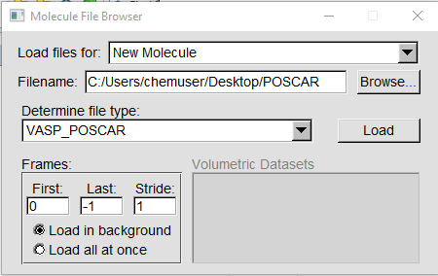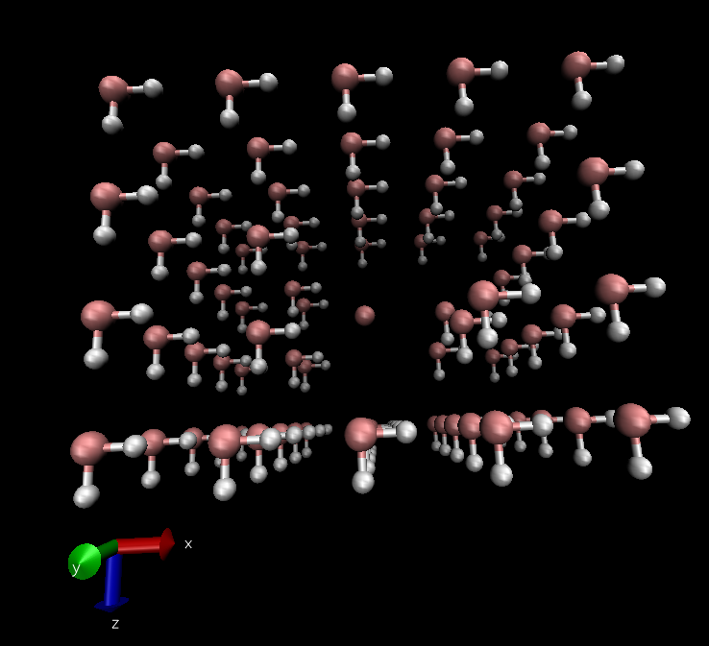

- Another fix is to hunt for duplicate atoms in Excel:
  - Copy and paste your POSCAR coordinates into excel.
  - Highlight all the cells that contain your xyz coordinates
  - Go to data>remove duplicates
  - If any were found, then you had duplicate xyz values.
- Another fast way…
  - Load your poscar into Avogadro
  - Copy the Cartesian coordinates, then convert to Direct in excel
- Another way:
  - Go to the OUTCAR file; control+F (find) and type ‘neighbor’
  - 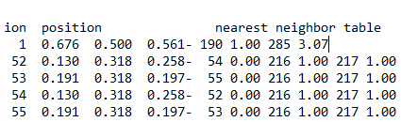
    - Look at the difference (negative sign) between the two ions; for example, 52 and 54 have a diff of 0 angstroms (a duplicate atom)
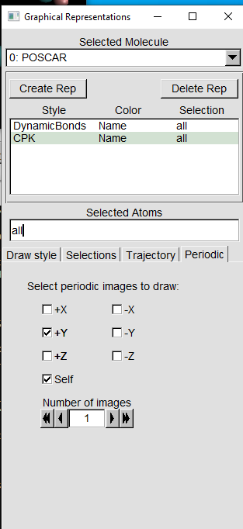
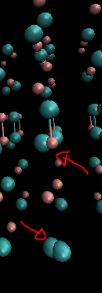
- If nothing is obviously close, and you’ve checked in excel for duplicate values, then go back to VMD, set graphical representations to periodic, and look for a too-close atom in a neighbouring cell! This was the problem at right. The fix is to increase your cell size in POSCAR.

Error messages such as

[1686756111.366853] [gra1037:6897 :0]
select.c:433 UCX ERROR no active messages transport to <no debug data>: posix/memory -
Destination is unreachable, sysv/memory - Destination is unreachable, self/memory -
Destination is unreachable, sockcm/sockaddr - no am bcopy, cma/memory - no am bcopy
...
MPIDI_OFI_mpi_init_hook(1471): OFI get address vector map failed
Abort(1091215) on node 3 (rank 3 in comm 0): Fatal error in PMPI_Init: Other MPI error, error stack:
MPIR_Init_thread(136)........:
MPID_Init(904)...............:
MPIDI_OFI_mpi_init_hook(1471): OFI get address vector map failed
srun: error: gra137: tasks 0-1: Exited with exit code 1
srun: launch/slurm: _step_signal: Terminating StepId=7133799.0
srun: error: gra139: tasks 2-3: Exited with exit code 1
srun: Job step aborted: Waiting up to 62 seconds for job step to finish.
srun: error: gra1037: tasks 4-11: Exited with exit code 1

generally mean that Graham couldn’t find the directory for your VASP job – you weren’t in the correct directory when submitting your sbatch command. If that does not work, try movimg your directory folder under your username directory (main directory under def-east/[username]

- How to analyze results

Excel: used to plot time-dependent properties, like energy and temperature.
“grep F OSZICAR > greplist.txt” will create a file to be read by Excel.

ein.exe, gk.exe, simp.exe: Fortran programs to compute conductivity and diffusion constants for simple molten salts. These require “old.dyna” files as inputs, so it would need
“vasp2viewmol > name.dyna” to create such a file. (Viewmol was a program we used to use to view molecular movies on an X-terminal (eg. Aufbau), and required the .dyna style of input.)

VMD: a freeware code used to view and study molecular movies on a PC. Requires the vasprun.xml file from a VASP run (or, possibly, the XDATCAR file might work too). Many details follow…

- VMD tips

Running VMD:

Copy a vasprun.xml file from one of your simulations to the PC (we use WinSCP).
Rename this file to something like HCl400K.xml or whatever your run directory was called.
Open VMD.
Go to FileNew MoleculeBrowse. Browse for this .xml file that was imported.
Click the Load button.

Graphics: (mainly Tiffany Hui’s tips)

To improve the ugly sticks representation in the VMD 1.8.6 OpenGL Display window, go to GraphicsRepresentations...
and select a coloring method, a drawing method, and a material. We recommend:
- Drawing Method: change Lines to Dynamic Bonds. Increase distance cutoff for inorganics.
- Create Rep (to layer on a 2nd representation for atomic balls
  - Change drawing method to CPK. Reduce bond radius to zero.
  - Change coloring method if you need greater variety in atom colours.

If you want to alter any property of certain types of atoms and not affect the other atoms, you have to create representations for them by clicking on Create Rep (still in the VMD 1.8.6 OpenGL Display window). Then you can select a representation in the window, click on the Selections tab, and clear whatever is typed under Selected Atoms. Choose a property under Keyword by double clicking it and double click on whatever it shows in the Value window beside it. This should type something under Selected Atoms. Then click Apply. Going back to the Draw style tab, you can manually adjust the size and other characteristics of the selected atom.

To manually change the color of the atoms, go to GraphicsColors... and select a category under "Categories". Then choose something under Name and pick a color (under Colors) for each choice under Name. Make sure that whatever you select under "Categories" matches what you select in the Graphical Representations window under Coloring Method. You can change the colors by adjusting the color bars.

I still haven't found out how to get the atoms to have different sizes according to their atomic radii. Supposedly, there is a way you can view the atoms with different atomic radii without having to manually adjust them.

Every time I load a new file, the image shows the nearest atoms larger than the atoms that are further away. To make the sizes of all the atoms the same go to DisplayOrthographic.

You can rotate the image in various ways by going to Mouse and choosing different modes.

VMD tips continued

Getting a radial distribution plot (g(r)) from VMD: (mostly Colin Kuntz’s tips)

Load up the desired movie. If you have continuations of the same simulation you can load them into one VMD movie by selecting “load data into molecule”.
For the g(r), go to ExtensionsAnalysis Radial Pair Distribution Function g(r). If you have separate movie files you can select which one you want the function for in the “Use Molecule” box. Now for the parameters…
Selection 1: The starting atom type. Use “name Bi”, or “name O”, etc.
Selection 2: The atom type for the distribution, e.g. “name Cl” or “name H.” The function will then compute the g(r) for the distribution of Cl’s around Bi’s, for example.
Frames: First: The first timestep for sampling. If you equilibrated in a previous run, starting at 0 is fine., but if the starting geometry of THIS run was bad, input the frame number at which equilibration seems achieved. Last: -1 means to go to the end of the movie file, otherwise specify what frame you want to end at. Step: You could sample only each nth step with this parameter, although every step (1) is recommended.
Histogram parameters: delta r is the size of bin (discretization of the function); defaults are probably fine.
To save results to a file (for inputting for Excel later), click the “save to file” box. Then click Compute G(r) to compute! The g(r) file gives you three columns: the first is the radius or distance r, the second is the g(r) at that r, and the last is the number integral at that r.

Measuring/plotting bond lengths/angles/dihedrals: (Colin Kuntz’s tips)

To select: go to Mouse >> Label >> select what you want to label, atoms, bonds, etc. Click on the atoms that you wish to highlight. If you selected bonds, VMD will draw a bond with the length indicated between the first two atoms you selected. You can do this as many times as you wish.

To graph: go to Graphics >> Labels. Select what you want to graph (atoms, bonds, etc) from the green drop-down box. It will then show all of the bonds that you labeled. You can then select which ones you want to graph by either clicking show or hide. If you hide bonds, it will turn off the highlighted bond on the movie screen, and VMD won’t graph it either. Use the movie screen to confirm which bonds you want to graph. Go to the Graph tab in the same Labels tab, and you can click Show Preview to display the graph onscreen. Press Graph to have VMD start graphing, and you can also press Save to save the data in a txt or dat file for plotting in Excel if you wish. You can also save the graph itself as a weird file type, but it’s probably easier to use Excel.

Obtaining coordination numbers (Justin Cayer):

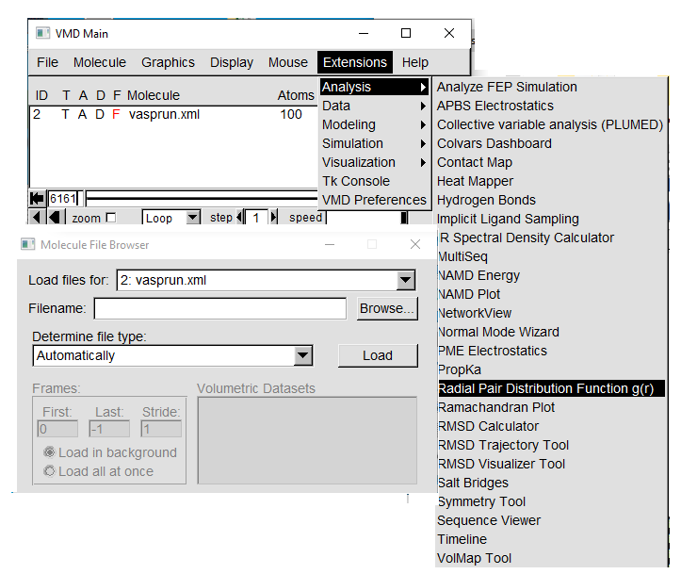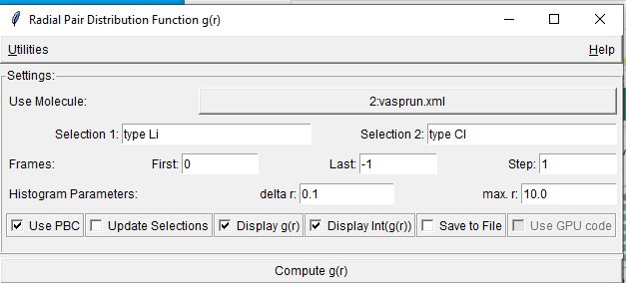

Central atom is selection 1, selection 2 is surrounding atoms, hit compute:
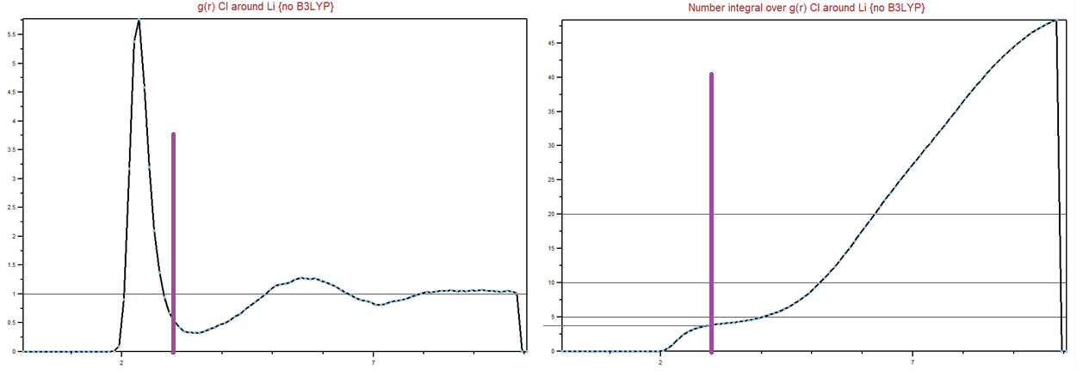

Making a .mpg movie file: (Allan’s tips, old)

1. Load an xml in VMD, set up the graphics and viewing angle and delete extra frames. Try to get to 1000 frames to satisfy 5Mb file limit.
2. Go to Extensions/Visualizations/Movie Maker.
3. Pick a working directory and movie name. Leave as Rock and Roll and MPEG-1.
4. When you hit Make Movie, you also have to run the VMD movie!!!!! Movie duration is not "smart" and you might see looping. Roughly, 38 s movie does 1000 timesteps of a hexyl ion movie.
5. When VideoMach's "Export Media" appears, go to Video/Resize to the ACS recommended 480x360, and Codec Settings.... click High Quality box.
6. Hit OK and Start. VideoMach will make the mpeg file.

Making Videos in VMD/ Using OBS: (Justin’s tips, 2023)

OBS is a freeware desktop recording software used by millions.
Download Open Broadcaster Software (OBS)
https://obsproject.com/download
Click on + icon under sources>window capture>window (dropdown)>[vmd.exe]>ok
Make sure ‘Capture Cursor’ is unchecked
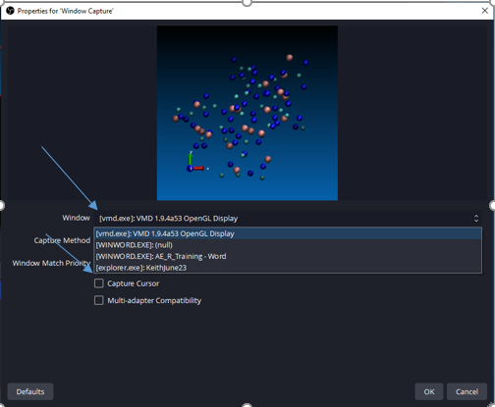
Resize if needed (drag corners).
MAKE SURE DESKTOP AUDIO SLIDER IS SET TO –inf dB; IT WILL RECORD AUDIO OTHERWISE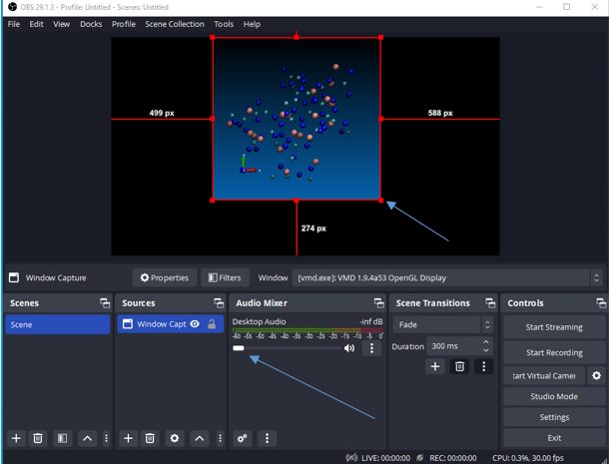

To change output pathway, click on settings under Controls>output>recording path>browse
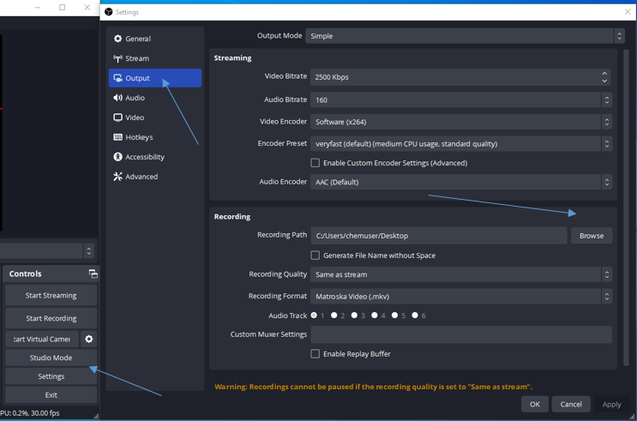

In settings under HotKeys, you can also designate buttons to record/stop recording.
To record, make sure you click “Start Recording” instead of “Start Streaming”
