Health and Safety, Human Resources
Email: health.safety@uregina.ca
Phone: (306) 337-2370
Happy New Year!
Many of us will reflect on the past year while also looking forward to new beginnings in 2024! It’s a great time to continue to prioritize self-care and create goals for our mental health and emotional well-being.
With the start of a new year, we are tempted to fall into the habit of declaring a “new year, new me” transformation. While this can be a positive way to focus on self-improvement, try cultivating attainable goals and begin 2024 with a “new year, improved me” mindset. Resist the urge to strive for an entirely new you. Instead, accept you as you are—last year, today, and throughout the New Year. The relationship you have with yourself is crucial to your own well-being and to creating healthy and happy relationships with others.
BE YOUR OWN BEST FRIEND
We’ve all heard the saying – “the most important relationship you will ever have is with yourself”. Being your own best friend is a concept rooted in self-love and self-care. It means developing a deep and compassionate relationship with yourself, prioritizing your well-being, and treating yourself with kindness and understanding.
So this New Year, instead of feeling pressure to make and stick to unrealistic resolutions, think about setting a SMART goal(s) for yourself that improves your mental wellness and makes your emotional growth a priority.
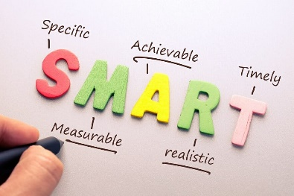
Out “SMART” THE NEW YEAR
Unlike resolutions, a SMART goal(s) provides clarity, focus, and motivation for achieving your specific goal(s). This goal(s) will empower you to seize control of the hours in your day, from a passive observer to an active participant. Take some time to think through what you want to achieve, and make this the mission statement for your SMART goal(s).
Take a look at the SMART acronym below
Specific – Be clear and detailed; your goal(s) will be even more meaningful and successful.
Measurable – Provides focus and helps you stay motivated; assess your progress to feel the excitement of getting closer to achieving your goal.
Attainable – Be realistic. Self-Awareness is crucial, be fully aware and ready to do what needs to be done.
Relevant – Gives purpose and aligns with what matters to you. Keeps you in control with your objectives and expectations.
Time-Bound – Track your success; celebrate small achievements along the way to your deadline.

Set aside some time for yourself; free from distractions. Think about your goal(s) ~~
Be kind to yourself as this may require a few attempts.
To help get you started, please view the SMART goal(s) video here

INITIAL | Write the goal you have in mind
GOAL
S | What do you want to accomplish? Who needs to be included? When do you want to do this? Why is this a goal?
SPECIFIC
M | How can you measure progress and know if you’ve successfully met your goal?
MEASURABLE
A | Do you have the skills required to achieve the goal? If not, can you obtain them? What is the motivation for this goal? Is the amount of effort required on par with what the goal will achieve?
ACHIEVABLE
R | Why am I setting this goal now? Is it aligned with overall objectives?
RELEVANT
T | What is my deadline and is it realistic?
TIME-BOUND
SMART | Review what you have written, and craft a new goal statement based on what the answers to the questions above have revealed
GOAL

2:12 minutes

