2023 ANNUAL REPORT FOR THE UNIVERSITY OF REGINA
TRUST AND ENDOWMENT FUND

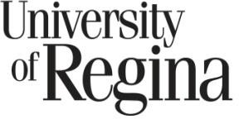

The University of Regina Trust & Endowment Fund – Overview
The University of Regina Trust & Endowment Fund (TEF) consists of 418 nonexpendable endowed trust accounts and 167 expendable non-endowed trust accounts. Each individual account was created for a specific purpose such as a scholarship and has terms of reference which govern the use of the funds. In addition, the University has institutional policies which govern the administration of the TEF with which each individual trust account must comply. As at December 31, 2023, the fair market value of the TEF was $142.0 million (2022 - $128.4 million). $139.8 million of the TEF was managed by contracted professional investment managers and $2.2 million was allocated to the UR Investing program in the Faculty of Business Administration.

Oversight of the TEF is provided by the Trust & Endowment Committee (TEC), which is a five person subcommittee reporting to the University of Regina Board of Governors. TEC members are employees and persons appointed by the Board of Governors. The TEC operates in accordance with terms of reference approved by the Board. The TEC makes operational decisions regarding the TEF and makes recommendations to the Board for approval on significant matters, in accordance with the terms of reference.

The TEC works closely with investment consultants, Aon, to monitor and manage the TEF. Annually, the Statement of Investment Policies and Goals is updated by the TEC with the advice of Aon. The TEF portfolio consists of diversified investment accounts investing in domestic and international equities, fixed income, real estate and infrastructure. The goal of the annual update of investment asset mix is to obtain the required rate of return for the TEF within an acceptable level of investment risk. The primary long-term objective of the TEF is to generate a minimum annualized rate of return after inflation of 4% which is the rate necessary to support an annual expenditure of 4% of the endowed trust accounts in perpetuity. This objective enables endowed scholarship funds to pay out annual scholarships of 4% of the fund balance forever while maintaining the purchasing power of both the annual scholarship and the remaining trust fund balance.

Later in this report, investment returns are compared to “benchmark returns.” Those benchmark returns are established in relation to specific investment asset classes and economic circumstances to assess investment performance, but the underlying primary objective remains to generate a real rate of return of 4% per year. As at December 31, 2023, the TEF exceeded this primary objective over the ten year investment period, however failed to exceed over the four year period.

Almost all TEF funds are invested as a pool of funds through several investment managers. The majority of the investment managers employed are also employed by the University of Regina Pension Master Trust Fund. By employing the same investment managers for the TEF and the University’s two defined benefit pension plans, each can be managed as separate funds, yet combined for investment manager fee calculations. This enables economies of scale to be reached which results in lower investment manager fees for both the TEF and the pension funds.

The one exception to all TEF funds being invested as a pool is in relation to the UR Investing program. Specific trust funds have designated that part of its assets be invested by UR Investing, with the resulting investment gains or losses being attributed directly back to those specific trust funds. UR Investing assets and investment returns are not comingled with the other TEF assets. As at December 31, 2023, $2.2 million of the TEF assets were managed by UR Investing.

UR Investing is a program within the University of Regina Faculty of Business Administration. It is a structured program for degree credit which enables University students to learn about investments using real money and investing in real stock market investments through an external stockbroker. The program is an example of the programs used to achieve the University’s strategic goal of providing students with experiential learning environments.

The remainder of this report has been written by investment consultants, Aon. The report analyzes in detail the performance of the investment portfolio held by the TEF. The purpose of this analysis is to provide past, present and future benefactors to the University of Regina with information regarding the sound investment management practices employed by the University of Regina to ensure that the maximum benefit is derived from their gifts to the University.

Review of 2023 Investment Performance

The Markets
After a difficult 2022, global markets rebounded in 2023. A major reason for the resurgence was monetary policy pauses by the major central banks and increasing expectations of rate cuts in 2024. Another important factor was the strong leadership of a handful of U.S. technology stocks that have been boosted by the Artificial Intelligence theme. Heading into 2024, the likelihood of recession, the trajectory of inflation, and the extent of rates cuts will be the key focus areas for the markets.

Equities
Global equities generated strongly positive returns over the last twelve months with the MSCI All Country World Index up 18.9%. Returns were driven by a small number of stocks branded the “Magnificent 7”. These seven stocks, Apple, Microsoft, Alphabet, Amazon, Nvidia, Meta Platforms and Tesla, accounted for 39% of the total MSCI ACW Index return in 2023, driven by Artificial Intelligence themes. U.S. Equities were the strongest region in the year, returning 26.3% in local currency terms, or 22.9% in Canadian dollar terms. Domestic markets also did well, with the S&P/TSX Composite returning 11.8%. As in the U.S., Information Technology was the strongest sector, returning 69%, with results driven by one single stock, Shopify, which returned 119% in the year, accounting for 20% of the Index return.

Fixed Income
Bond yields ended 2023 near the same level they started, with the yield for the FTSE Canada Universe Bond Index falling from 4.28% at the end of 2022 to 3.94% at the end of 2023. However, it was a volatile year for bonds as yields moved meaningfully throughout the year, as see in the chart below. Yield shifts during the year reflected the market’s view on interest rate expectations and monetary policy. After raising rates three times in the first half of the year, the Bank of Canada held rates steady at 5% citing growing evidence that past rate hikes are having their intended effect on the economy and inflation. Overall, the FTSE Canada Universe Bond Index returned 6.7% in 2023.

Canadian Real Estate
The Canadian commercial real estate market posted a 0.0% return (MSCI/REAL PAC Annual Property Index) in 2023. With the MSCI/REALpac Canada Quarterly Property Fund Index returning a weaker -2.0% return in the year. Rising capitalization rates and headwinds in office properties, along with macro-economic uncertainty drove negative returns in the real estate market.

Global Infrastructure
The Global infrastructure market posted a 1.7% return (DJ Brookfield Global Infrastructure Index) in 2023. High inflation and higher than normal interest rates were themes for the year, leading to difficult market conditions for Infrastructure investors.

Plan Overview

Investment Performance (excluding UR Investing) - 2023

- The University of Regina Trust and Endowment return was 10.5% in 2023.
- The Total Fund return lagged the 10.9% benchmark return. Value subtracted was driven by asset allocation and with the Fund overweight Real Estate in a strong equity and bond market, and weak performance in Infrastructure relative to the CPI + 5% benchmark.
- Asset class results included:
  - Canadian Equities – PH&N’s 12.5% return exceeded the 11.8% S&P/TSX Composite Index, while Mawer lagged the Index, earning 10.5%. For PH&N, stock picks in Industrials, Communication Services and Real Estate added value. Mawer’s stock selection detracted value, particularly in the Info Tech sector. An overweight allocation towards Info Tech along with underweight allocations to Materials and Energy sectors partially offset the underperformance.
  - In the U.S. equity market, BlackRock’s performance tracked tightly to the 22.9% S&P 500 return, which is the objective for this passive strategy.
  - The non-North American equity manager, Mawer, exceeded the 12.5% MSCI All Country World ex USA Index, earning 14.3% in the year. Mawer’s added value was driven by an overweight to the Industrials sector and strong stock picks in Materials, Health Care and across most sectors.
  - BlackRock manages emerging market equities passively for the Trust and Endowment Fund and tracked the MSCI Emerging Market Index in the year, earning a 6.5% return.
  - PH&N manages mandates in Universe Bonds and Mortgages. Over the year, PH&N’s bonds returned 7.6%, adding to the 6.7% FTSE Canada Universe Bond Index return. Mortgages returned 7.2% versus the 5.0% FTSE Canada Short Term Bond Index. PH&N primarily holds investment grade bonds, with 6.4% of the portfolio in bonds rated below BBB. The breakdown of the bond quality is shown in the graph below.
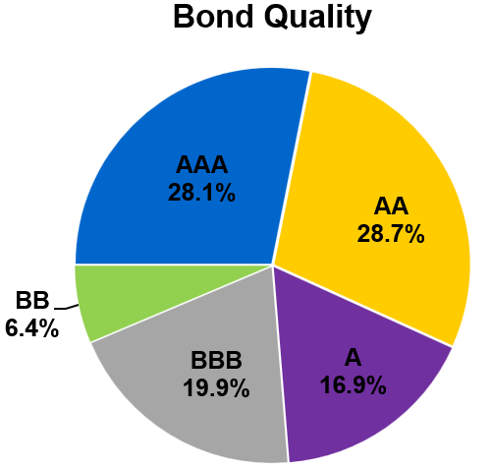

  - The BlackRock Absolute Return Bond strategy invests in global fixed income assets, and generally has low interest rate sensitivity, to shield against the negative impacts of rising interest rates. In the year, the strategy returned 6.4%, below the 9.3% USD LIBOR +4% return target. The BlackRock strategy has a 3.3-year duration, versus the 7.3-year duration for the Universe Bond Index, meaning it has less than one-half of the interest rate sensitivity and can be expected to do comparatively better in a rising interest rate environment.
  - Real estate is managed by Bentall, and TD Greystone. Real estate returns took a step back in 2023, with Bentall earning -4.2% and TD Greystone earning 0.7%. Capital depreciation led the decline due to the increase in rates causing valuations to decline.
  - KKR global infrastructure was added in March as the fund switched to an active mandate and the passive BlackRock global infrastructure mandate was exited. In the nine full months since inception, KKR returned 1.7%.

Investment Performance – Rolling Four-Year Returns
- One of the Fund’s investment objectives is to exceed the benchmark return over rolling four-year periods. The Total Fund return over the past four years was 6.0%, lagging the benchmark by 0.5%. Four-year underperformance was mainly due to below index performance from GMO in global equities, as their value style was out of favour over this period. BlackRock absolute return bonds have trailed over the past four years but delivered strong diversification for the plan. The following chart provides the longer-term track record of the Fund, with each period a rolling four-year result. Over the past 10 years, the Total Fund return was 7.5% per year, which was 0.2% below the benchmark return.

Investment Performance – Relative to Peers

- In addition to monitoring performance relative to the benchmark return, the Fund performance can be put in perspective by comparing the result against those of a universe of institutional funds. The following table shows the Total Fund return and individual asset class returns relative to other funds in the Aon Peer Universes over the past year and four-year periods.
- The 2023 Total Fund result of 10.5% placed in the third quartile of the Balanced Fund Universe, below the 10.9% return earned by the median fund. Over the past four years, the Total Fund return of 6.0% trailed the 6.2% median fund result.

2023 RELATIVE PERFORMANCE
Asset Class | 2023 Quartile 1 | 4-Year Quartile 1
Canadian equities | 2 | 3
U.S. equities | 2 | 2
Non-North American equities | 3 | 4
Emerging Market equities | 3 | 3
Bonds | 2 | 1
Mortgages | 3 | 3
Real Estate | 1 | 3
Infrastructure | n/a | n/a
Total Fund | 3 | 3
1 Indicates the placement of the return relative to the Aon Universe for institutional pooled funds. Quartile 1 include the top 25% of funds by return, Quartile 2 represents firms in the 26-49% range, M is the median return, and so on.
- Asset class performance relative to respective universes of peer managers were mixed. In Canadian equities, PH&N was second quartile over both periods, while Mawer struggled versus peers, placing in the third and fourth quartile over one and four years respectively. Similar to Canadian equities, Mawer’s non-North American equity strategy struggled relative to peers, over one and four years. BlackRock manages passive US and Emerging market equities, and the peer group results indicate that active management was rewarded in the emerging markets over these periods, but not in the U.S. Mortgages were below the peer universe median over one and four-years due to the conservative style PH&N employs. Real Estate results were mixed, with TD Greystone above median over both periods and Bentall below.

Primary Investment Performance Objective

While investment performance objectives for the Trust & Endowment Fund were lower than the Total Fund benchmark return over rolling four-year periods and below the median returns within a peer universe, the primary long-term objective is to earn in excess of a 4% real rate of return over the longer term. The real return is assessed as the Total Fund nominal return, net of inflation, as measured by the Canadian Consumer Price Index. The Total Fund real return was 2.2% over the past four years and 4.9% over the past ten years, on an annualized basis, below the 4% real return objective over 4 years and substantially surpassing over 10 years.

Benchmark Portfolio Return and Asset Mix

- The benchmark portfolio return is calculated by using index returns and target asset class weights. The current policy asset mix is shown below. Within the various asset classes, the
objective is to exceed the relevant index return for actively managed mandates, and to track within 0.10% (U.S. Equity) and 0.35% (EM Equity) of the relevant index for passively managed mandates. In addition, the returns are evaluated on a relative basis to a universe of other investment manager returns.
- A new benchmark was selected and implemented in 2023, removing Global equites and splitting the allocation between U.S. and Non-North American equities.

Asset Class | 2022 Benchmark Portfolio (Market Value %) | 2023 Benchmark Portfolio (Market Value %)
Canadian equities | 16% | 16%
U.S. equities | 11% | 19%
Non-North American | 11% | 19%
Global equities | 16% | -
Emerging Market equities | 4% | 4%
Core Plus Bonds | 12% | 12%
Absolute Return Bonds | 5% | 5%
Mortgages | 5% | 5%
Real estate | 10% | 10%
Infrastructure | 10% | 10%
Short-term investments | 0% | 0%

The Trust and Endowment Fund
At the end of 2023, the Trust and Endowment Fund assets had a market value of $139.8 million (excluding $2.2 million of the TEF assets managed by the UR Investing program). This is up from $126.4 million at the end of 2022, due to capital gains and investment income.
The distribution of assets for the Trust and Endowment is shown below.

Asset Mix Summary

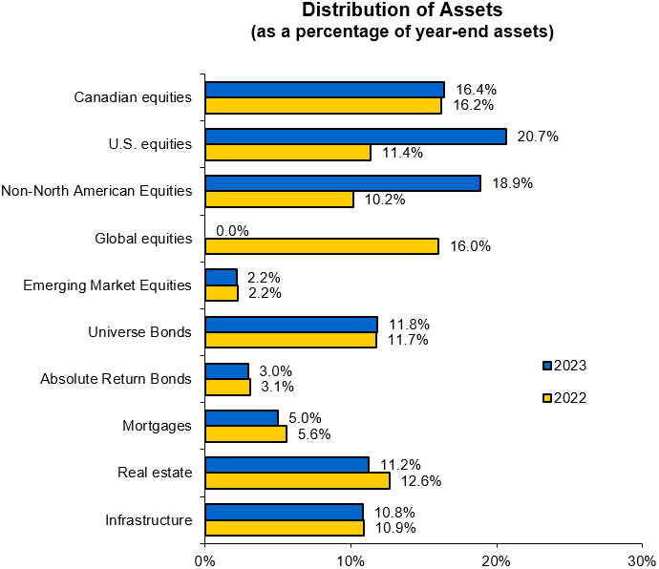
Distribution of Assets by Manager

At the end of 2023, PH&N managed 24.7% of the Trust and Endowment Fund assets in a domestic balanced mandate (Canadian equities and fixed income). Mawer manages both a Canadian and a non-North American equity mandate. BlackRock manages passive U.S. equity, Emerging Markets equity funds, and a global absolute return bond strategy. Bentall and TD Greystone oversee the investments in real estate. KKR manages the investments in Infrastructure.

Manager Mandate 2023 2022
PH&N Domestic Balanced 24.7% 25.0%
Mawer Canadian and NNA Equities 27.4% 18.7%
BlackRock U.S. Equities, EM Equities, and
Absolute Return Bonds 25.9% 16.7%
GMO Global Equities 0.0% 16.0%
Bentall Real Estate 5.4% 6.2%
TD Greystone Real Estate 5.9% 6.4%
BlackRock Infrastructure 0.0% 10.9%
KKR Infrastructure 10.8% 0.0%
Cash Account Liquidity 0.0% 0.0%
100.0% 100.0%

