University of Regina’s

Career Connect

Employer Manual

Contents

Career Connect 3

To Register for a Career Connect Account 3

To Login to Career Connect 3

Forgot Password 3

Navigation 4

Job Postings 5

Post a New Job 5

Contact Information 5

Job Posting Information 5

Application Method 7

Application Information 7

Complete the Posting 7

Repost a Job 7

Interviews 9

Rankings 10

Enter a Ranking 10

# Career Connect

The University of Regina’s Career Connect portal is your access to Co-op and Internship students at the U of R.

With our new system, employers will now have the ability to complete these activities within their Career Connect account:

* Post positions for Match and Post-Match hiring periods
* Review Interview Schedules
* Enter Match Rankings
* Review all past and current job postings and placements

Any employer who has posted a position since January 2022 will already have a Career Connect account. Please refer to the Forgot Password instructions below to access your account.

## To Register for a Career Connect Account

Employers are welcome to register for their own Career Connect Employer account. All account requests will be reviewed by Co-op staff. Employers will be notified by email if their account has been approved and then can begin to post positions.

1. Open a browser and navigate to <https://careerconnect.uregina.ca>.
2. In the top right, hover your mouse over Employers and click Account Registration.
3. Complete all fields and press Continue.

## To Login to Career Connect

Once an account has been approved, employers can login to Career Connect using the login credentials created when the account was registered.

1. Open a browser and navigate to <https://careerconnect.uregina.ca>.
2. In the top right, hover your mouse over Employers and click Employer Login.
3. Enter your Login ID (email address) and Password.

## Forgot Password

1. Open a browser and navigate to <https://careerconnect.uregina.ca>.
2. In the top right, hover your mouse over Employers and click Forgot Password.
3. Enter your Login ID (email address) and click Email Reset Password Link.
4. Follow the instructions in the Reset Password Email to access your account.

# Navigation

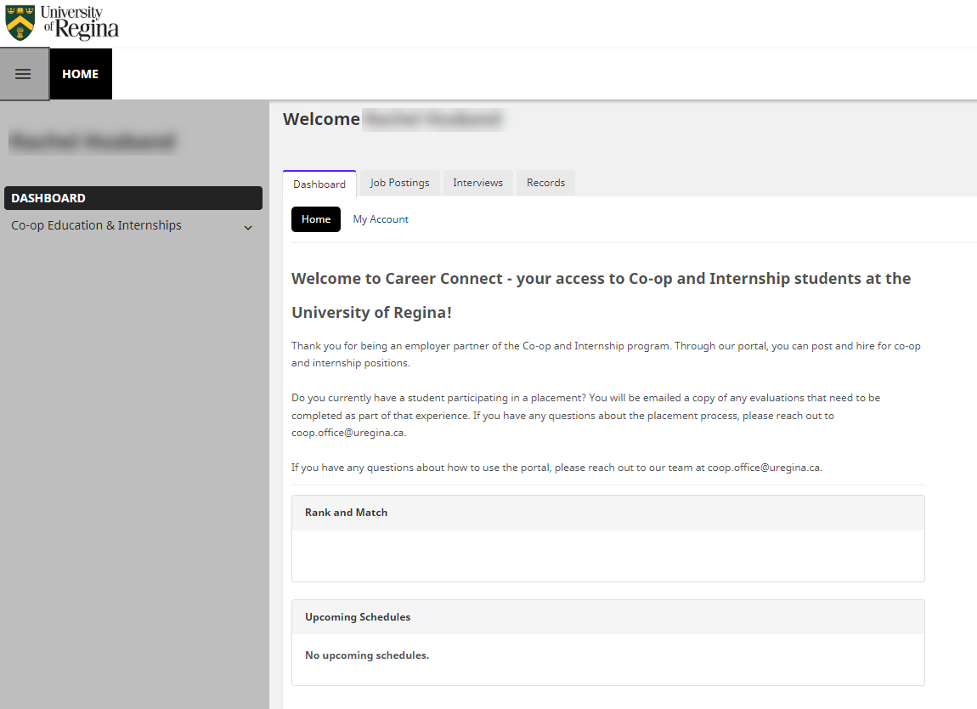

**Top Navigation Menu**

Dashboard tab - Review account settings including your account information and password changes

Job Postings tab - Review all your current and historical job postings

Interviews tab - Review all your Interview Schedules

Records tab - Review all past and current employment records

Rank and Match - During the Match period, you will be able to click View Rankings to submit rankings

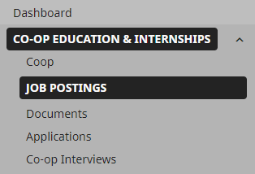**Co-op Education & Internships**

From the left hand navigation menu, select a menu item to create or review those items.

# Job Postings

On the Job Postings page, you can review all your current and historical job postings, post new jobs, and repost previous job postings.

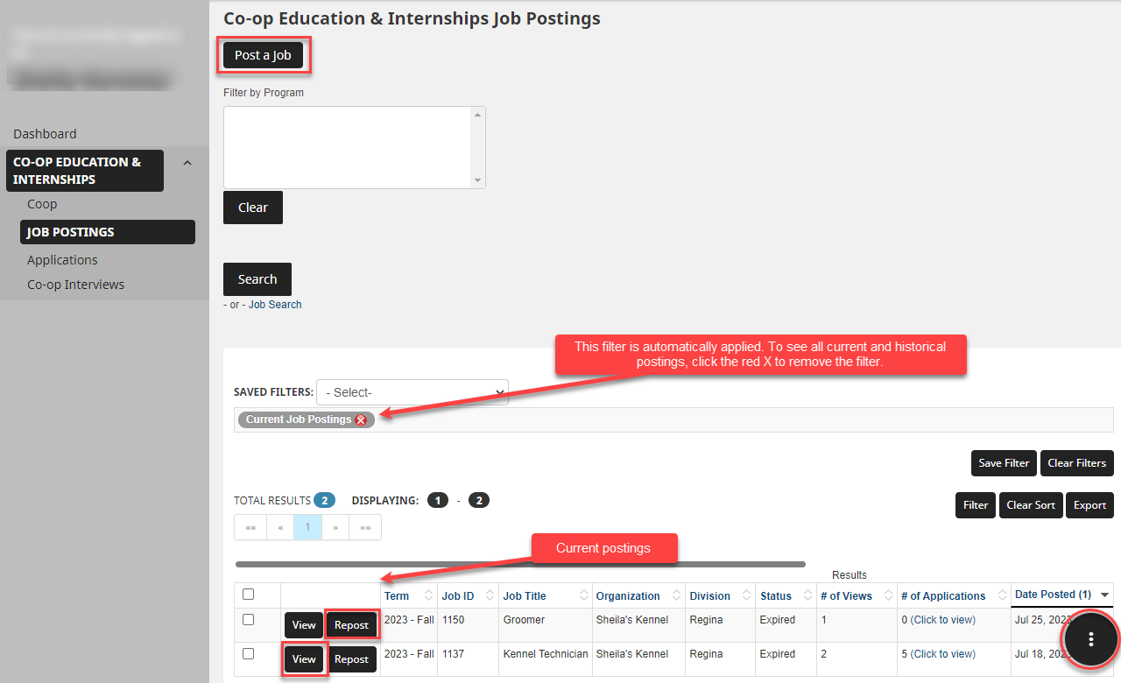

## Post a New Job

1. Click on Co-op Education and Internships and then select Job Postings.
2. Either click on Post a job at the top of the page

OR

Click the three dots in the lower right hand corner and select Post a Job.

1. Click Post a New Job.

### Contact Information

1. On the Job posting page, Contact Information will automatically populate. To change this information, press Clear Contact Info and enter the new information.

By updating the job posting form with new information, this will be a onetime change only. To make permanent account changes, click My Account on the Dashboard.

### Job Posting Information

In this section, you will enter the information regarding the job posting. All required fields will be identified by a *.

1. Term Posted – this is the term when the job opportunity will be take place. For example, a job is posted in September but the Term Posted will be Winter.
2. Complete all other required fields.
3. Targeted Degrees and Disciplines – **this is an important part of the set-up.** The selections made in the targeted degrees and disciplines will restrict or allow students to apply to the job posting.

**Targeted Degree and Discipline options**

* 1. To welcome applicants from any program, please select the Cluster titled **All Programs**.

**OR**

* 1. Select a Cluster to include all the programs within that cluster.

For example: The Technology Cluster will allow applications from Computer Science, Software Systems Engineering, Electronics System Engineering students.

* + 1. Select the Cluster.
    2. Once the Cluster is selected, the programs associated with that cluster will populate in the program area.

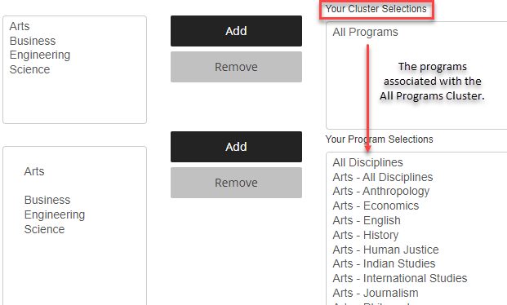

**OR**

* 1. Select only Programs. If none of the clusters really work for the position, select the specific programs individually.
     1. Do not select the Cluster.
     2. In the programs area, click each program and press Add to add it to the programs list.

NOTE: After you select the program, it will automatically apply a Cluster. Don’t worry, only the selected program will be included

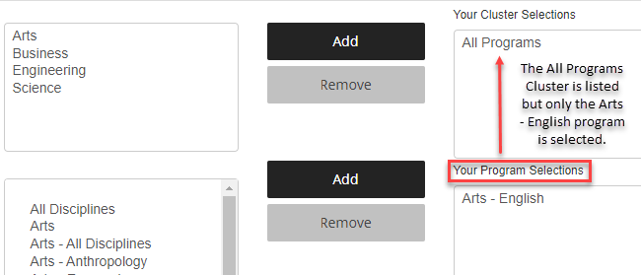

### Application Method

1. To have applications forwarded once the job posting has closed, select **University of Regina Co-op Portal**. Enter all email addresses that should receive the applications. Applications will automatically be sent at 10 am on the day after the job posting closes.
2. To have students apply directly through an employer portal, select **University of Regina Co-op Portal AND the Employer Website**. Enter the URL students should apply at. Enter all email addresses that should receive applications or select Do not email applications to not receive an emailed application packet.

### Application Information

1. Enter the Application deadline.
2. Select all the required Application documents. Note that the Cover Sheet will be the standard Co-op Cover Sheet and not a traditional Cover Letter.

### Complete the Posting

1. To review the posting, press **Preview Posting**. Press Close in the bottom right hand corner to return to the previous page.
2. To submit the posting, press **Submit Posting for Approval**.

All job postings will be reviewed by the Co-op Office. When the posting has been approved and posted, a notification will be sent via email.

## Repost a Job

Career Connect allows employers to repost previously posted jobs with updated dates.

1. Click on Co-op Education and Internships and then select Job Postings.
2. Find the job posting and select **Repost**. Remember, the default setting is to filter and show only the current job postings. To see all your job postings, click the red X to remove the filter.
3. Choose either **Quick Repost** or **Repost and Edit Posting**.

**Quick Repost** – use this option to update only the posting term and the application deadline.

* 1. Select the Term.
  2. Select the Application deadline.
  3. Press Repost. The job will automatically be submitted for Co-op Office approval.

**Repost and Edit Posting** – to make edits to the posting and the dates, use this option.

1. Select the Term.
2. Select the Application deadline.
3. Press Repost.
4. The job posting will open. Make any required changes.
5. Press Submit Posting for Approval.
6. Once the repost has been submitted for approval, the job will be listed on the Job Postings page.
7. To edit the posting, click Edit Posting. Make any changes and press Submit Posting for Approval.
8. The status column will show the most recent status for the job posting.

Pending – the job posting will show as pending until it has been approved

Approved – the Co-op Office has reviewed and approved the posting

Rejected – the Co-op Office has not approved the posting

Expired – the job application deadline has passed

Note: Postings can only be edited until they have been approved. After a job posting is approved, any edits will need to be made by the Co-op Office. Please contact your Co-op Coordinator or [coop.office@uregina.ca](mailto:coop.office@uregina.ca) to make any edits.

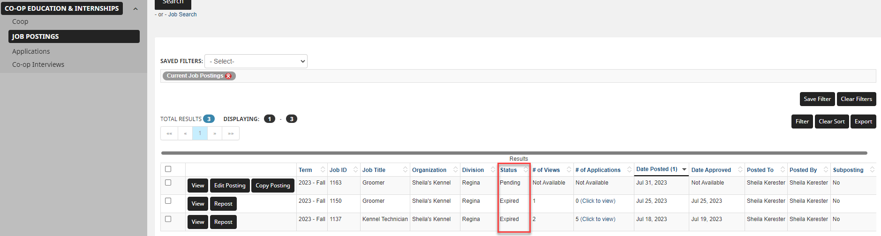

# Interviews

Once applications have been reviewed, please complete the [Interview Request Form](https://www.uregina.ca/careercentre/coop/assets/docs/pdf/interview-request-form.pdf) and submit it to [coop.office@uregina.ca](mailto:coop.office@uregina.ca).

After the Co-op Office schedules the interviews, the Interview schedule can be reviewed in Career Connect:

1. On the Dashboard, click the Interviews tab.
2. All scheduled interviews will be listed. Review details by using the horizontal scroll bar to review all interview settings.

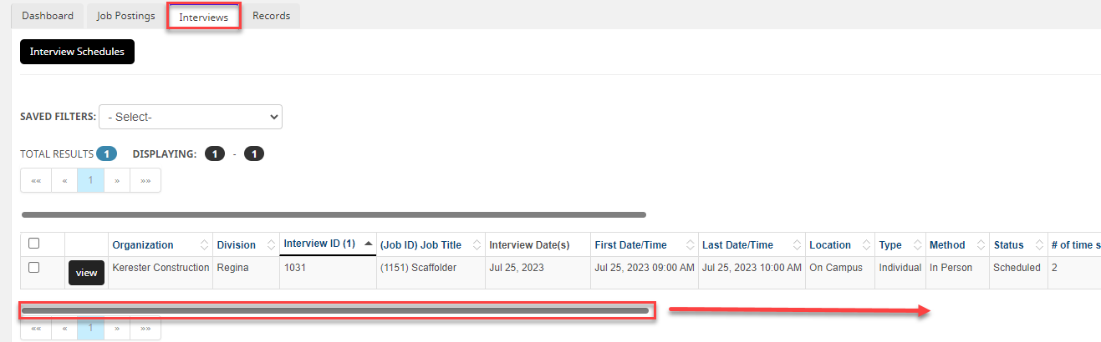

1. To view which students have signed up, press view.

The Co-op Office will continue to email out finalized interview schedules one day prior to the interview date.

# Rankings

In Career Connect, employers will now be able to enter their own rankings. Employers will be able to enter rankings anytime during the Match interview period. The ranking period will end on midnight of the last day of the interview period. Please check the updated Employer calendar to review Match dates - <https://www.uregina.ca/careercentre/coop/for-employers/schedule/index.html>.

It is best if employers post their own rankings directly into the Career Connect system. This minimizes the chances of

## Enter a Ranking

1. Login to Career Connect.
2. On the Dashboard, under Rank and Match click **View Co-op Education & Internships Coop Ranking**.

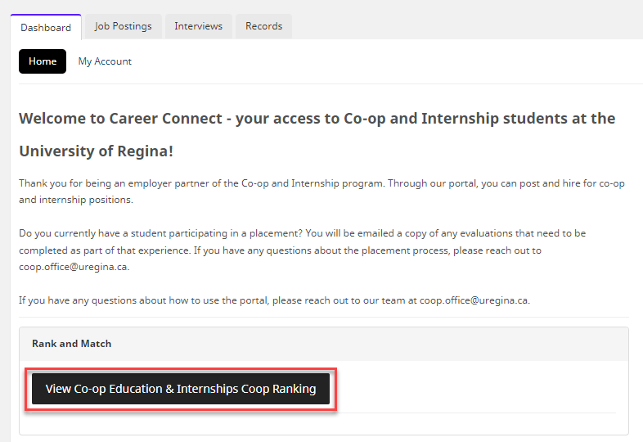

1. The jobs in included in the Rank and Match round will be listed. Select the job and click Submit Rankings.

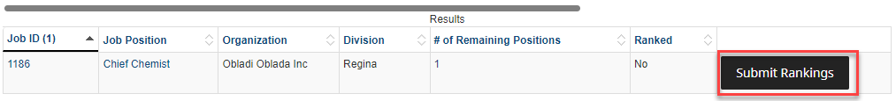

1. The Ranking form will appear. Ensure that the details of the offer are completed including work term dates, job location, salary, payment frequency, and hours per week.
2. In the Note to Student, enter any extra details including parking, bonuses, etc.

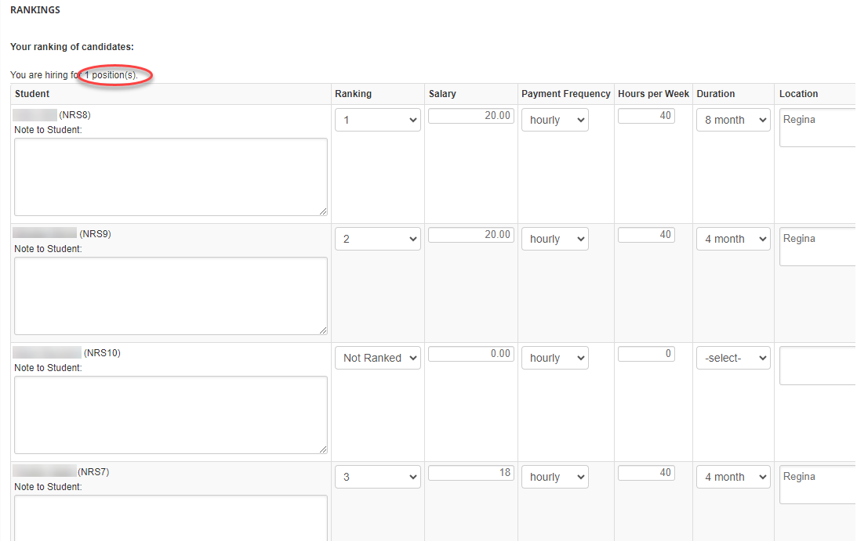

1. Once rankings have been entered, press **Save Rankings**.
2. Log into Career Connect after Match Day to review matches.

**Note: The number of #1 rankings used must equal the amount of positions being hired for (as indicated on the job posting). To make MORE offers than open positions, the Co-op Office will need to adjust the job posting. Please get in touch with a Co-op Coordinator to make this change.**

## Review Matches

After the Match, employers can review who they have been matched with in Career Connect. There are multiple places where a match can be reviewed.

Method A

1. Login to Career Connect.
2. On the Dashboard, under Records you can review all the student hires by Co-op term. You can review all Co-op hiring for a semester here.

Method B

1. Login to Career Connect.
2. Click Co-op Education & Internships in the left-hand menu and choose Job Postings.
3. Find the position that you would like to review and press **View**.
4. Click on the **Work Term Records** tab and the matches for that position will show.
5. Review each job posting separately to find which student has been placed into that position.