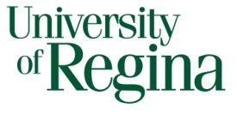
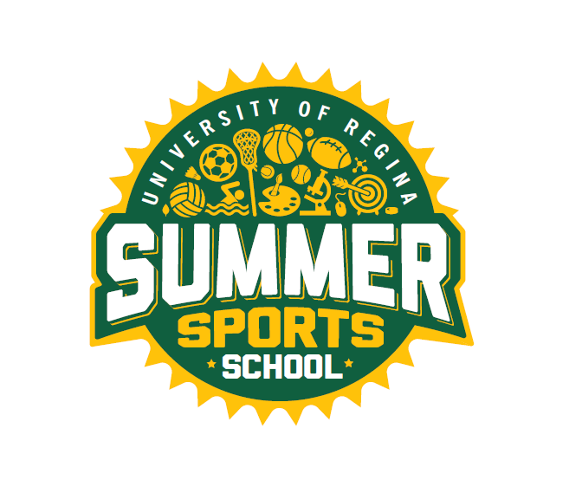

SUMMER EMPLOYMENT OPPORTUNITIES

Faculty of Kinesiology and Health Studies
RECREATION SERVICES

Invites applications for

SUMMER SPORTS SCHOOL
for the summer of 2024

Positions: Visual Art Instructors

Full time position available

Terms: June 23rd – August 23rd, 2024
Monday to Friday
Full time: 8 hours/day
(Times may vary slightly)

Duties: To provide leadership, instruction, and supervision of children in various visual arts activities.

Requirements: MUST:
- Be a returning student in the Fall
- Preference to those in the Faculty of Education, Visual Arts Major
- Have related field work experience
- Be enthusiastic and creative
- Demonstrate strong leadership skills
- Have excellent organization and communication skills
- Able to plan a variety of visual art activities
- Work well with children
- Have CPR/First Aid
- Criminal Record Check

How to Apply: Drop off a cover letter and résumé to:

Logan Neumann
Community Program Assistants
Intramurals Sports Office
Room CK 172, Centre for Kinesiology Health and Sport
University of Regina
Regina, SK
S4S 0A2

Or send via email to khs.youth-programs@uregina.ca

Closing Date: 11:59 p.m. Friday, March 1st, 2024 or until positions are filled

The University of Regina is committed to employment equity.
We encourage applications from all qualified applicants.

